[**CIS 634 OBJECT ORIENTED SOFTWARE ENGINEERING SECTION 50**](https://bb-csuohio.blackboard.com/webapps/blackboard/execute/courseMain?course_id=_129878_1)

**GROUP PROJECT QUESTIONS**

**QUIZ APPLICATION**

**Group 8-** Group Assignment

**Group members:**

1. **Bheemavarapu kavya Chowdary**
2. **Nuthakki Bhargav**
3. **Chakkala Sai Pujith**

Q1 - What architectural design patterns did you use for your application? Architectural design pattern includes MVC, layered architecture, repository architecture, client-server architecture, pipe and filter architecture, or other architectures (for example, Event-Driven Architecture - AWS Lambda, MapReduce architecture, etc.). Please draw your application's overall architecture to indicate components and actors if your system includes them.

**For quiz application, we have used client and server architecture. The client will send http request to the server and the server will fetch the data from database and process.**

**The application was build using MERN stack. Mongo DB, Express, React and Node js**

**CLIENT-SERVER ARCHITECTURE**

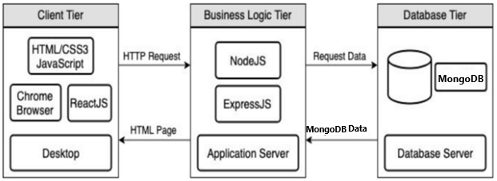

Q2 - What is your kernel (most sophisticated) component? Please use one or more of the five models (process model, use case diagram, sequence diagram, class diagram, state diagram) to describe it.

**This is a sequence diagram, This diagram will clearly explain the interaction between the objects and it will show the process or working of application**

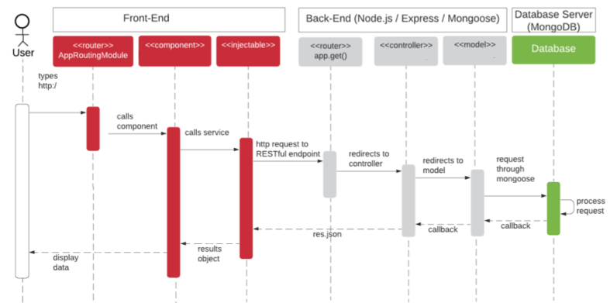

Q3 - What design patterns have you used during design and implementation? If yes, please attach the related source codes or give us a link to these source code (for example, you can host in Github as public). If not used, please explain why object-oriented design patterns cannot be used for your application.

**SINGLETON DESIGN PATTERN.**

**In this project we have used singleton design patterns and rest api ‘s. Please find the link below for the project source code**

**https://github.com/kavyabheemavarapu/Quiz-Application-CIS-634**

Q4 - What testing tools have you used for your application (such as JUnit, .NET Unit Testing Tool, Apache JMeter for load testing, etc.)? If yes, please attach the related source codes or give us a link to these source codes (for example, you can host in Github as public).

**MOCHA & CHAI.**

**QUIZ application, as its build on MERN stack we choose mocha and chai for unit testing the application.Its still in the process not yet fully implemented.**

**Please find the source code for unit testing using mocha and chai using the below link.**

**https://github.com/kavyabheemavarapu/Quiz-Application-CIS-634**

